Go-No-Go Secure Messaging

**Date:** July 17, 2023

10 am Est

# Agenda

* Review purpose of Go-No-Go (Lauren)
* Review what Phase 0 means and rules (Lauren)
* Demo of SM product (Coulton, Bryan, Dimitar, Oleksii)
* Discussion of risks
* Discussion of next steps
* Discussion of Phase 0 exit criteria
* Vote

## Purpose of Go-No-Go

## Phase 0 Overview

Application exists on VA.gov in a published, **authenticated** state, but can only be found if users know the URL.

- Authenticated includes all login.

## Phase 0 User Access

User links directly to new VA.gov tool via link provided in email.

MHV, My VA Health, or VA.gov will not link to the tool.

New tool will include “return to MHV” or “return to My VA Health” links.

## Demo

1. Discussion of the current language around emergencies.
   1. Dr. Josephs would like the names of who would like call local.
   2. **ACTION ITEM:** Get final approval of new language
2. Discussion of the word “Trash” and “Archive”

## Discussion of risks/known issues

* 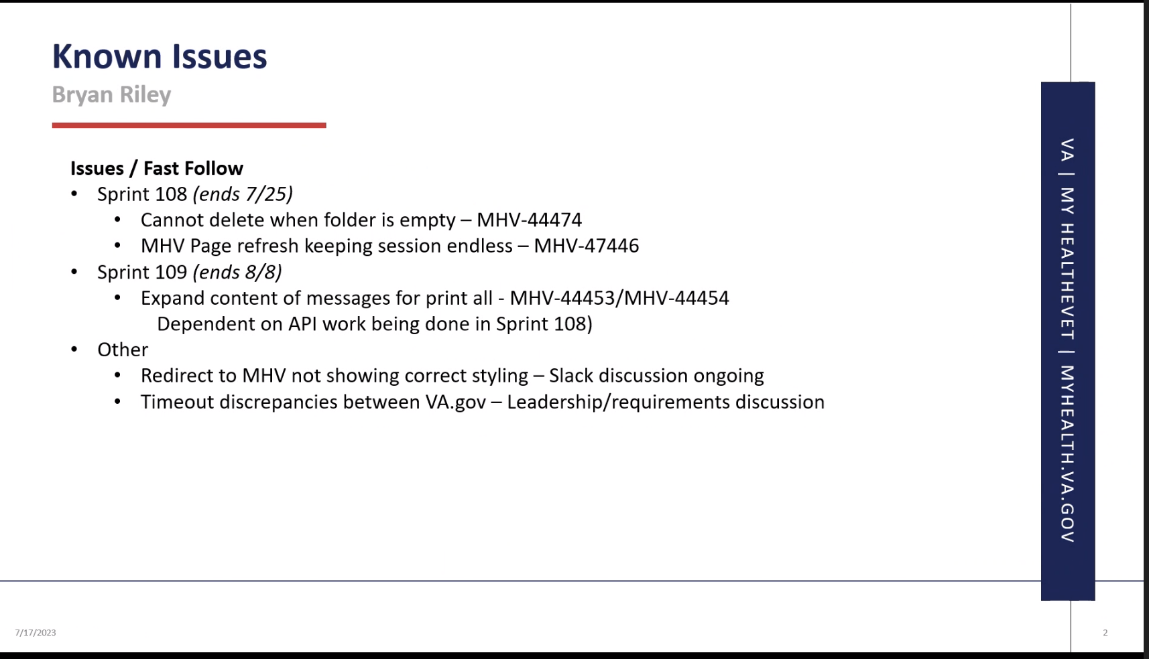
* **Need to verify with VHA whether we need to surface language around local contact center (Dr. Josephs to vet with Theresa / Patti)**

## Next steps if GO:

* Communications will send out appropriate notifications
* Coulton and Patti to set up time to review feedback w Tracey.
* Lauren to send out emails to Phase 0 participants
* Team (lauren, coulton, leila, mark, bryan) to monitor feedback inbox and work with Bryan and Lichelle to log tickets as needed
  + **Action item:** Make sure that coordinators are in the know about any issues we are finding.
* Lauren to notify OCTO teams.

## Phase 0 Exit Criteria/ Phase 1 Entrance criteria

* Have critical design or development bugs been addressed?
  + Includes any critical (function blocking) issues identified by Phase 0 users.
  + Lauren to sign-off that critical design and development issues have been addressed.
* At least 250 secure messages have been successfully sent
* At least 250 secure messages have been successfully received
* Alert to go on MHV ready
* API load tested
* Redirects from MHV on VA.gov landing page ready
* Return to MHV Classic and My VA Health in place
  + Users can quickly and seamlessly return to MHV Classic or My VA Health without having to log back in or leverage any other workarounds
* Communications prepared
  + Critical internal groups notified
    - Including contact centers.
* Vote to move to Phase 1

## Vote

|  |  |
| --- | --- |
| OCC Leadership: Dr. Josephs / Theresa Hancock | GO |
| Patti Henry | GO |
| Lauren Alexanderson | GO |
| Communications | GO |
| Bryan Riley/Olekskii Morgun / Joel Calumpong | GO |
| Coulton Bunney/Leila Rassi/Mark Dewey | GO |
| Greg Kirk | GO |